Standard Subsystems Library (SSL)
Introduction
The Standard Subsystems Library (SSL) is a set of universal functional subsystems that can be used in 1C:Enterprise configurations to implement standard functions. This is a kind of "constructor" of ready-made solutions that allows you to speed up development and unify the functionality of various solutions. Its use is especially useful when creating complex configurations with standard mechanisms: authorization, reports, data exchange, files, integrations, and much more.
Subsystems can be used in the developed configuration both together and separately. From the point of view of implementation technology, all SSL subsystems can be divided into two categories:
- Subsystems implementing "independent functionality". They are implemented by simply transferring functionality ("implemented and forgotten") and do not require significant additional settings.
- Integrated subsystems provide functionality intended for use in certain objects of the consumer configuration (the so-called "tight integration"). During implementation, it is necessary to determine the composition of the consumer configuration objects for which the functionality needs to be implemented, and then perform a certain number of additional settings, make changes to the code and forms of the selected objects.
Using SSL when developing your own applications significantly reduces the amount of work, since it allows you not to waste time on creating frequently used mechanisms, such as access management, print, reports, working with files, which are found in almost all business applications.
From the point of view of 1C terminology, SSL is also a configuration, but not intended for automating a specific business, it simply containing mechanisms that can be borrowed into another software solution.
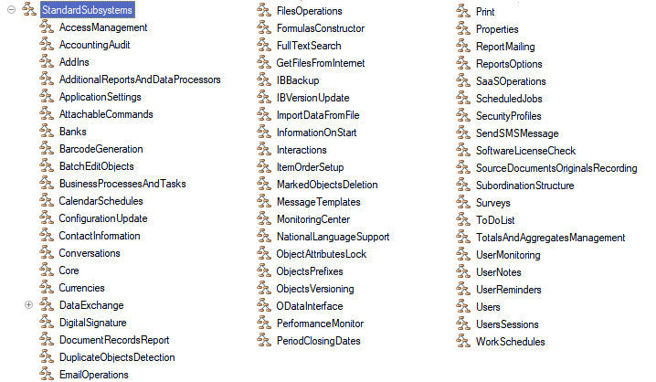
The number of subsystems in the SSL is gradually growing, which leads to an increase in the size of this configuration. Therefore, when building your own solutions based on SSL, it is recommended to include only the necessary subsystems. In the case of 1C:Enterprise product libraries, "subsystems" should be understood as sets of metadata objects included in a particular subsystem (metadata type "Subsystem"), i.e. these can be common modules, common commands, reference books, constants, data processors, scheduled jobs, etc.
Subsystem "Core"
The SSL has a subsystem "Core", which includes the general modules "Common", "CommonClient", etc. This subsystem provides universal procedures and functions for working with configuration, metadata objects, value collections, etc. For example, when you need to initialize a new array, place a single element there, and then assign this array to a variable or property of an object/collection, you can use the CommonClientServer.ValueInArray(<Value>) function, which creates a new array, places the value passed to the parameter in it, and returns the array. That is, instead of two or three lines
ObjectNames = New Array;
ObjectNames.Add("Catalog.Warehouses");
FillingParameters.ObjectNames = ObjectNames;
you can write everything in one line:
FillingParameters.ObjectNames = CommonClientServer.ValueInArray("Catalog.Warehouses");
I recommend that you familiarize yourself with the contents of the common modules of this subsystem, you will find a lot of useful information there.
We will consider the use of several frequently used subsystems in the following lessons. These will be the subsystems "Additional reports and data processors", "Print", "File operations". At the same time, we will not consider the implementation of the library of standard subsystems in the configuration, because this requires a lot of time, and instead we will study on the ready-made configuration "Standard Subsystems Library (demo)", I use the version of the library 3.1:
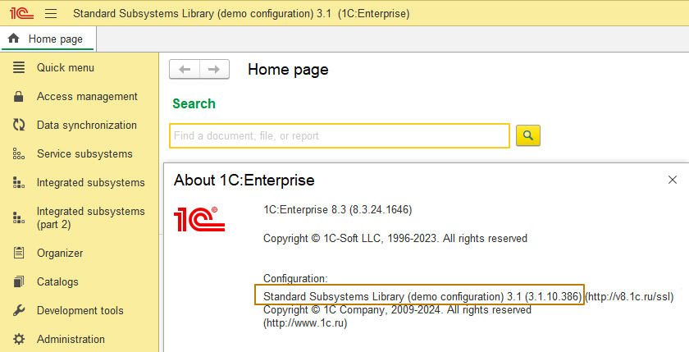
And we will start with the subsystem "Additional reports and data processors", which expands the capabilities of working with external reports and data processors.
Additional reports and data processors
The "Additional reports and data processors" subsystem allows you to:
- connect external reports and data processors to the application, customizing their display in the interface, user access to them
- link to specific objects, for example, to perform actions to fill objects
- use as new print forms or as a replacement for built-in print forms
- scheduled execution of data processor
- tools for administrating the list of additional reports and data processors
Depending on the purpose, additional reports and data processors can be global, if used in general for the configuration, or assigned, if used with specific types of information base objects. Assignable data processors are divided into four types according to its functionality:
- for filling an object
- print forms
- for creating objects based on other objects
- reports
In order to manage additional reports and data processors in the application, they need to be registered in the information base. Reports are registered from external report files (files with the .erf extension), and other types of data processors are registered from external data processor files (files with the .epf extension). Both reports and data processors must meet certain requirements so that they can be registered in the information base with the "Additional reports and data processors" subsystem.
Let's consider the process of adapting an external data processor for use in the "Additional reports and processing" subsystem. To do this, I save the data processor for import prices from Excel from the lesson on data processors to the external data processor file.
The first requirement for registering a report or a data processor is the presence in the object module of the export function ExternalDataProcessorInfo() (the function name is the same for reports and data processors), which supplies information about the connected object, returning the structure of a certain composition.
Function ExternalDataProcessorInfo() Export
The structure itself should be initialized by calling the ExternalDataProcessorInfo() function of the common module from the AdditionalReportsAndDataProcessors subsystem:
RegistrationParameters = AdditionalReportsAndDataProcessors.ExternalDataProcessorInfo();
A description of the structure properties, as well as how it should be filled, can be found in the description block, which is located above the function in the common module:
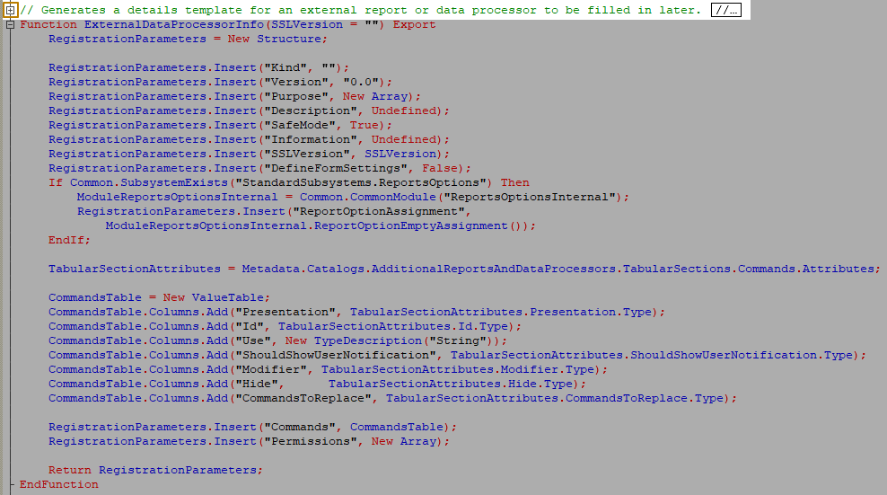
Information: According to the 1C language development standards, export procedures and functions must be accompanied by a clear description that explains the purpose of the method, parameters, and for functions, also the return value. This is necessary so that any developer using these procedures and functions can easily understand how to use them correctly. You can create such a description in two ways:
- Write commented text in the lines preceding the procedure or function
- Right-click on the line with the procedure or function declaration and then click the "Document procedure"/"Document function" button in the Refactor submenu:
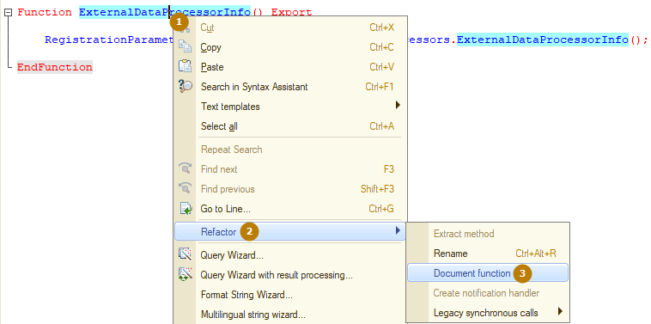
So, I expand the function description and see that we can pass the SSL version number as a parameter, but this is not required, so I will not pass this parameter. The return value is of type Structure, the properties of which are listed after the "*" symbol below with an indent from the parent collection/object:
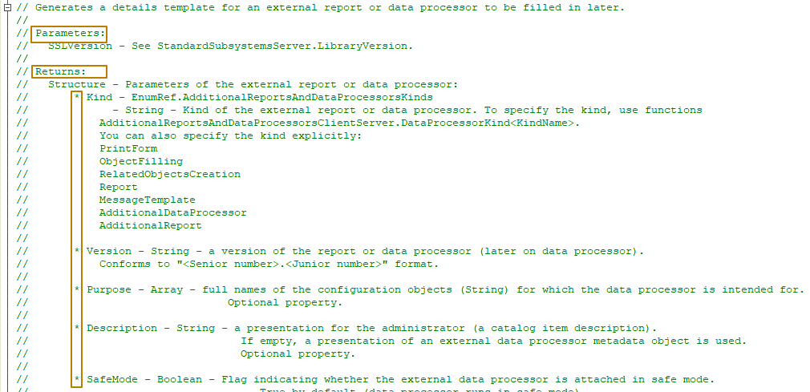
You can also see that if there are nested properties/columns, they are specified after an additional indent and an additional "*" symbol (i.e. "**", "***", etc.):
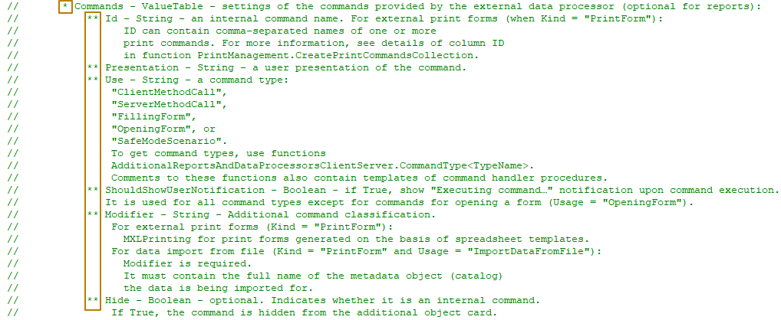
Not all properties of this structure are required to be filled, so let's consider the required properties, the values of which determine the performance of our data processor, as well as optional, but also important to study properties.
The first property is "Kind" of the string type, which can be filled explicitly with one of the values: PrintForm, ObjectFilling, RelatedObjectsCreation, Report, MessageTemplate, AdditionalDataProcessor or AdditionalReport, but it is better to fill the kind by calling the "DataProcessorKind<KindName>" function of the AdditionalReportsAndDataProcessorsClientServer common module, for example, the function DataProcessorKindAdditionalDataProcessor() will suit my example:
RegistrationParameters.Kind = AdditionalReportsAndDataProcessorsClientServer.DataProcessorKindAdditionalDataProcessor();
The next property to fill in, "Purpose", is responsible for which objects external data processor can be applied to. It is filled in with an array of full names of metadata objects, for example, "Document.PurchaseOrder" or "Catalog.Products". This property is not mandatory to fill in, however, for some types of data processors, for example, PrintForm, ObjectFilling, it is better to fill in this property, since such additional data processors is not intended for independent use (the object filling fills certain objects...).
Example of use (array initialization is allocated in a separate function):
RegistrationParameters.Purpose = DataProcessorPurpose();

Function DataProcessorPurpose()

Result = New Array;
Result.Add("Document.PurchaseOrder");
Return Result;

EndFunction
I skip this property, because my data processor is not related to specific objects.
The "Version" property is intended for storing the version of the data processor/report (for example, the data processor is released with version 1.0, when minor changes are made, the minor version is increased: 1.1, 1.2..., when significant changes are made, the major version is increased: 2.0, 2.1…).
RegistrationParameters.Version = "1.0";
The "Information" property contains a brief description of the external data processor; it is recommended to describe the capabilities or logic of the data processor for the administrator.
RegistrationParameters.Information = "Data processor for product prices import from Excel file";
The "SafeMode" property is used to enable or disable the safe mode during report or data processor execution. The default value is True, so it can be filled in only if it is necessary to disable the safe mode, I skip filling it in.
The "Commands" property contains a value table in which it is necessary to reflect the data processor commands (the property is not required to be filled in for reports), one data processor can contain several different commands. For example, data processor that is planned to be launched in the scheduled task mode (operations launched on schedule without user intervention) can contain 2 commands: one for filling in the settings in the form, which will then be used in the scheduled job, and the other for starting the task and starting some data processing. For additional data processor with the PrintForm type, you can make several print form commands in one data processor, differing slightly, when the logic for filling them is common, for example, "Commercial invoice" and "Commercial invoice with discounts".
The table contains the following columns:
- ID - internal command name
- Presentation - user presentation of the command.
- Use - command type:
- "ClientMethodCall",
- "ServerMethodCall",
- "FillingForm",
- "OpeningForm",
- "DataImportFromFile".
To obtain command types, it is recommended to use the functions
AdditionalReportsAndDataProcessorsClientServer.CommandType<TypeName>.
The descriptions to these functions also provide templates for command handler procedures.
- ShowNotification - if True, then when the command is launched, the notification "The command is running..." is displayed. Valid for all types of commands, except for commands for opening a form (Use = "OpeningForm").
- Modifier - additional classification of the command.
- For external print forms (when Type = "PrintedForm"): "PrintMXL" - for print forms based on table layouts.
- For loading data from a file (when Type = "PrintedForm" and Usage = "LoadingDataFromFile"): the modifier is required to be filled in and must contain the full name of the metadata object (reference book), for which the data is loaded.
- Hide - optional. An indication that this is a service command. If set to True, the command is hidden in the additional object card.
I add one row to the command table, and fill the Use property with the OpeningForm command type:
NewCommand = RegistrationParameters.Commands.Add();
NewCommand.Presentation = "Import product prices from Excel";
NewCommand.ID = "ImportData";
NewCommand.Use = AdditionalReportsAndDataProcessorsClientServer.CommandTypeOpenForm();
These actions are enough to try to connect external data processor to the mechanism of additional data processors of the information base. The most important thing is not to forget to return RegistrationParameters, otherwise the data processors will not be able to be connected to the information base:
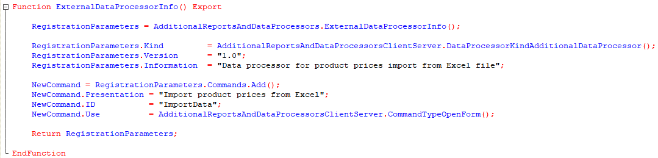
Do not forget that you can always independently study all the properties of the RegistrationParameters structure by reading the description of the return value in the function ExternalDataProcessorInfo() of the common module AdditionalReportsAndDataProcessors.
Now I save the external data processor and launch the Standard Subsystems Library (demo) infobase, where I open the Administration - Print forms, reports and data processors section:
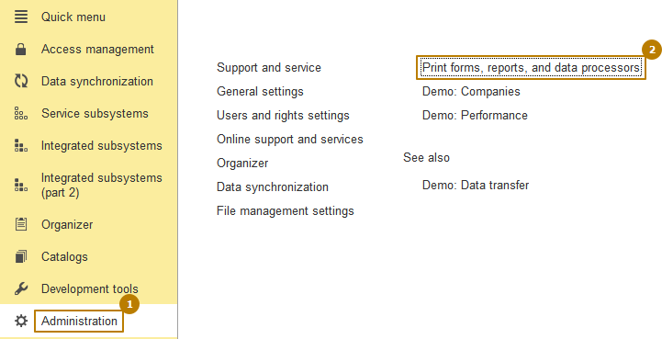
In the section that opens, you need to make sure that the "Additional reports and data processors" flag is enabled, then click the "Additional reports and data processors" hyperlink next to this flag.
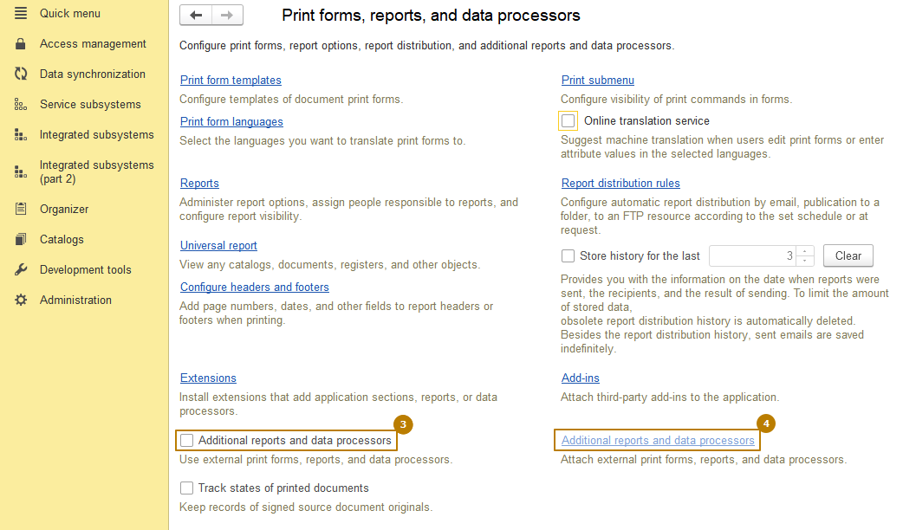
In the opened form of the list of additional reports and data processors, I must click the "Add from file…" button
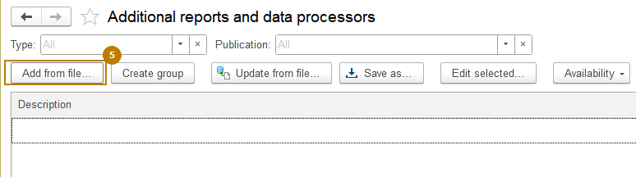

In the window that opens, I agree with the warning information
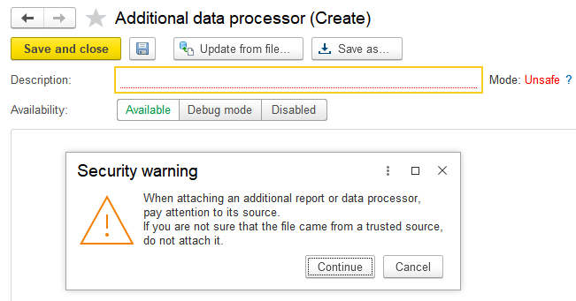
I select the external data processor file
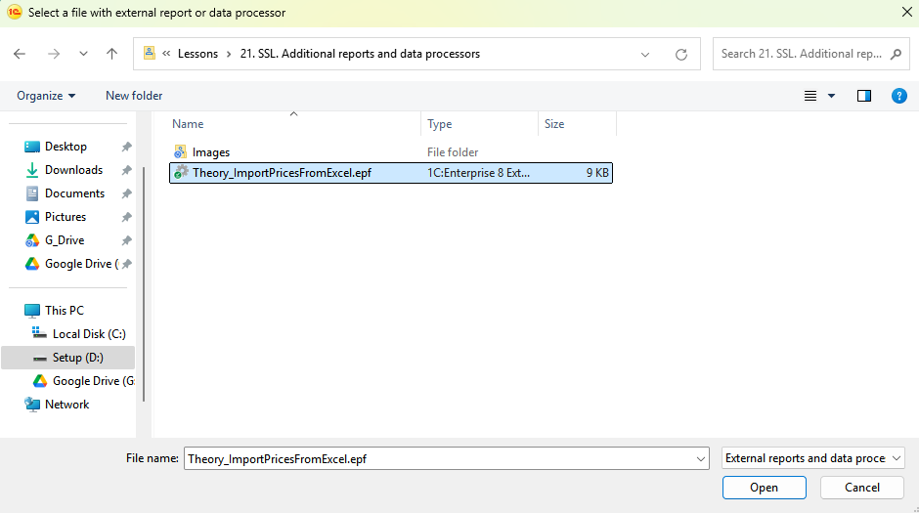
and see the list of data processor commands on the Commands tab:
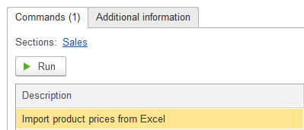
The "Additional information" tab contains a multi-line field that displays the value of the "Information" property from the external data processor information. Below this field is information about the data processor version, its type, file name, and object name.
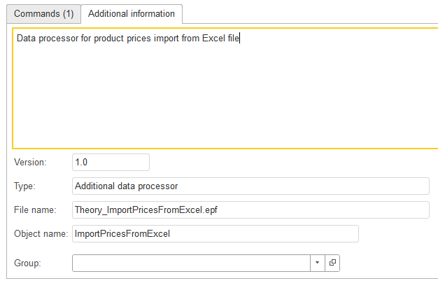
The first element on the Commands tab is the "Sections" field, followed by a hyperlink with the text "Undefined". In this field (by clicking on the hyperlink), you can specify in which subsystems this data processor should be displayed in the Tools - Additional data processors submenu for use by users.
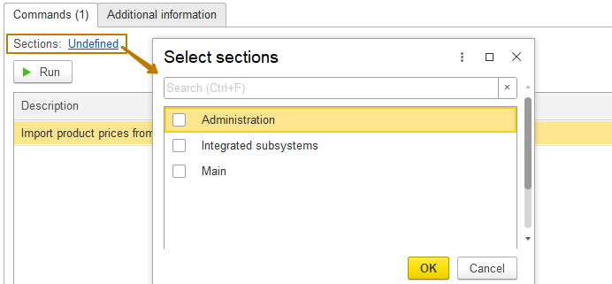
Of course, users with rights to view additional reports and data processors and the Administration subsystem can run external reports and data processors directly from their item forms using the "Run" button, but this is not so convenient, and ordinary users are rarely given such rights. Therefore, it is better to place reports and data processors in subsystems to which they are more relevant in meaning.

Please note that not all subsystems are listed in the window that opens, but only those that are listed in certain methods among the objects of the AdditionalReportsAndDataProcessors subsystem, as well as in the SSLAdministrationPanel data processor. If it is necessary to add the ability to specify other subsystems in the SSL-based configuration, they must be listed in the GetSectionsWithAdditionalDataProcessors() procedure of the AdditionalReportsAndDataProcessorsOverridable common module.
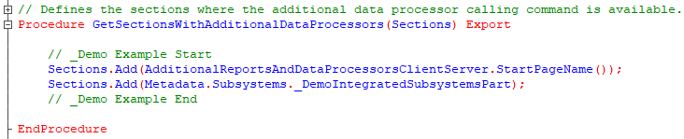
Important: common modules with the Overridable postfix in the name are intended to change the behavior embedded in the functionality by the developers of the subsystem without changing important objects of the subsystem and to make it easier to update the library in the future. That is, library developers intentionally create such common modules in which other developers can make the changes necessary for their configuration, while all the main algorithms for the operation of the subsystem are located in other modules, without the Overridable postfix.
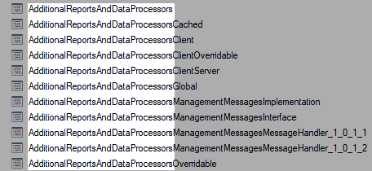
In order to make changes to the SSL common module, you need to remove the ban on changing the configuration object in the configuration support settings. To do this, I go to the "Configuration - Support - Support options" section, in the window that opens, I need to click the "Enable the ability to change" button and agree that from now on, a fully automatic update of the configuration will be impossible.
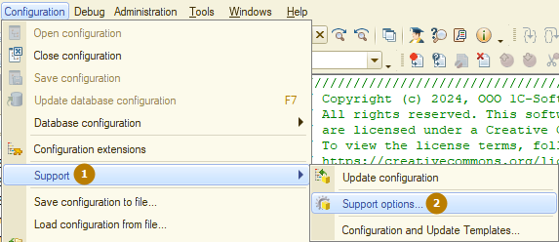
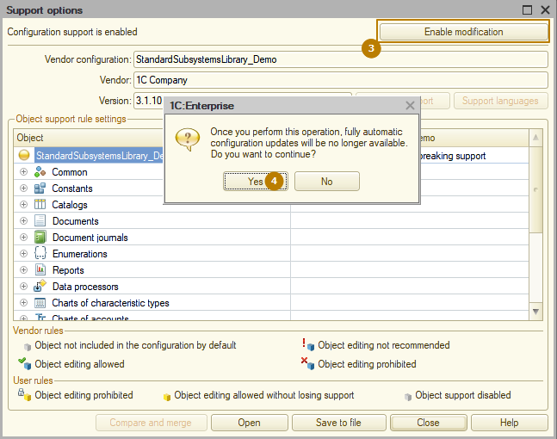
Then, in the support rules settings window, you should simply click OK without changing anything
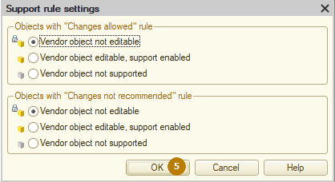
After all these actions, you can proceed to enabling the ability to change for the common module. To do this, you should find it in the list of configuration objects in the same "Support options" window and double-click on it in the column with the configuration name (to the right of the Object column):
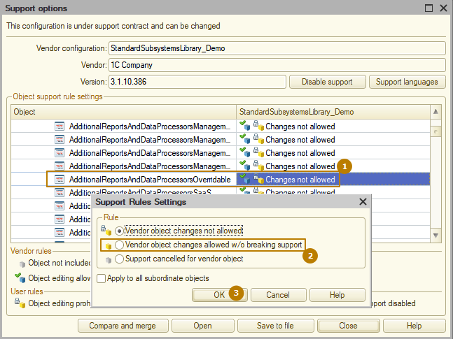
In the window that opens, select the support rule "Changes are allowed w/o breaking support" and click the "OK" button, as a result, the module will look like this in the list of objects:
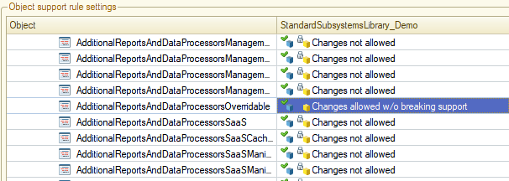
In order to add your own subsystem to the configuration (like any other non-subordinate metadata object), you need to enable changes to the configuration root in the same way. Here the process completely repeats the actions already discussed.
I enable changes to the configuration root, close the support options window and create a new Sales subsystem.
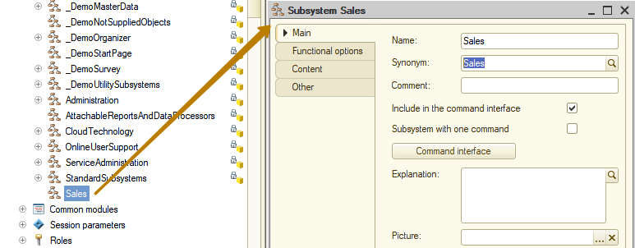
Next, I return to the AdditionalReportsAndDataProcessorsOverridable common module, where I can now make changes to the GetSectionsWithAdditionalDataProcessors() procedure. I copy one of the procedure lines, paste it and change the subsystem to the one I just created.
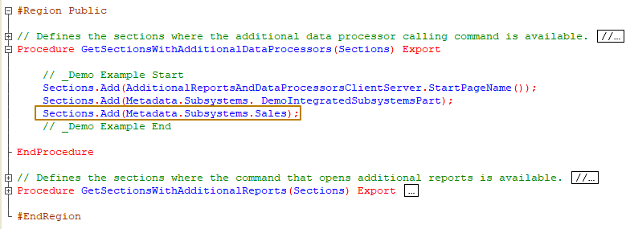
Now the last change remains to add the "Additional data processors" command to the Sales section - you need to create a common command with a name based on the "AdditionalDataProcessors<SubsystemName>" template, as is done with the three existing commands
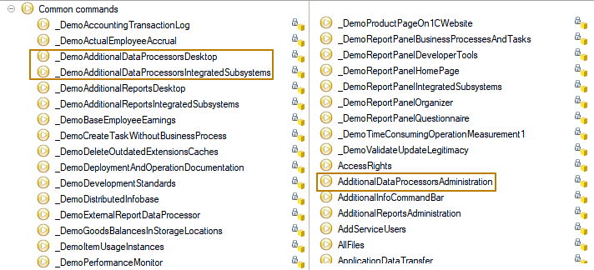
After creation, this command should be placed in the Sales subsystem, and also included in the "UseAdditionalReportsAndDataProcessors" functional option (for which you also need to enable the ability to change in the configuration support settings) so that the command is not displayed in the interface when the functionality of additional reports and data processors is disabled.
A new command can be created by copying from the AdditionalDataProcessorsAdministration command:
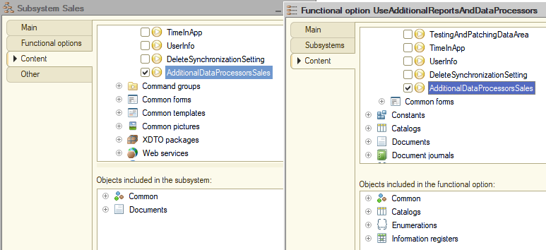
The last step is to change the value of the last parameter of the called procedure from "Administration" to "Sales" in the command module.
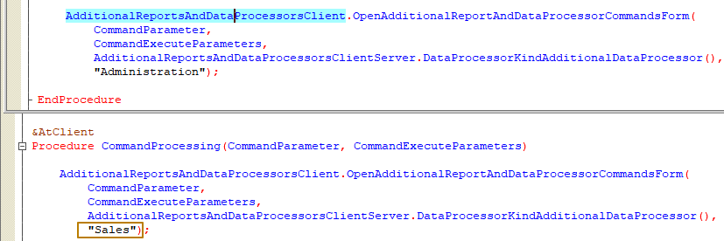
After that, I update the configuration, launch the infobase in Enterprise mode and see that the Sales subsystem has appeared in the interface and it contains the "Additional data processors" command. If the "UseAdditionalReportsAndDataProcessors" functional option were disabled, the command would not be displayed in the interface. This would lead to the Sales subsystem becoming empty, so it would not be displayed in the interface either, because the platform analyzes the need to display a subsystem/section at startup and when calling the RefreshInterface() method (when the functional option is enabled, the subsystem with additional reports and/or data processor will be displayed in the interface).
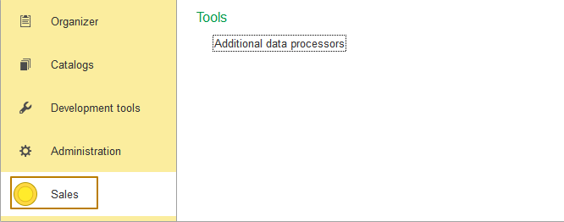
Now I return to my previously saved additional data processor, where I click on the hyperlink and mark the "Sales" subsystem for selection
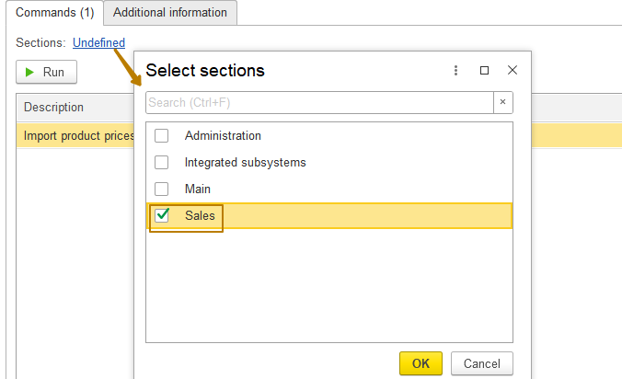
After that, I go to the "Sales" section and click the "Additional data processors" command. You can see that the list in the window that opens does not contain any elements.
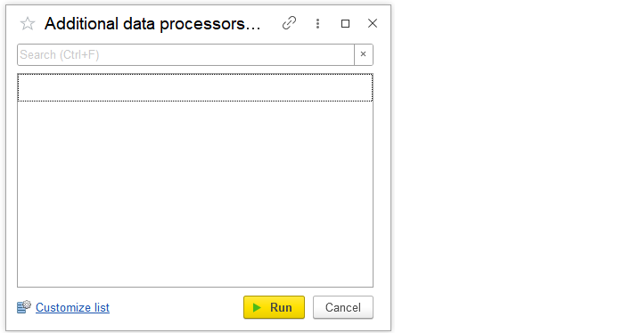
This is because the visibility of additional reports and data processors is configured by default for users in the "Quick access" column, and there are no users in my database
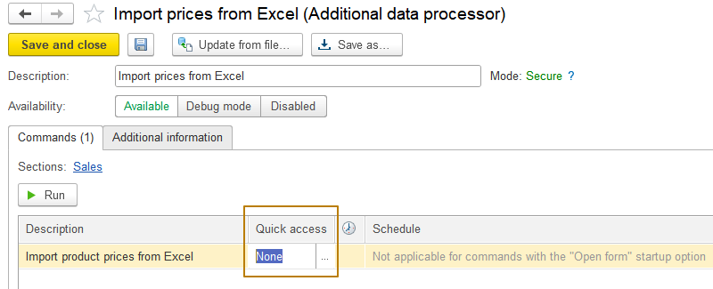
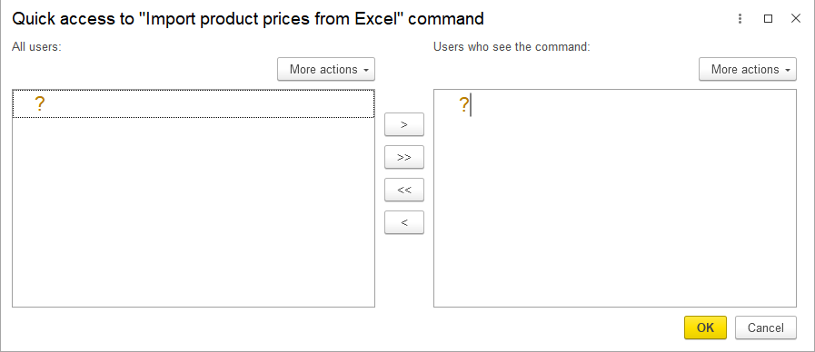
But I will show how you can configure the visibility of reports or data processor for an unauthenticated user. To do this, I return to the list of additional data processors in the "Sales" section and click the "Customize list" hyperlink there, in the window that opens, I enable the flag opposite the additional data processor I created, then click OK and see that the data processor has now appeared in the list.
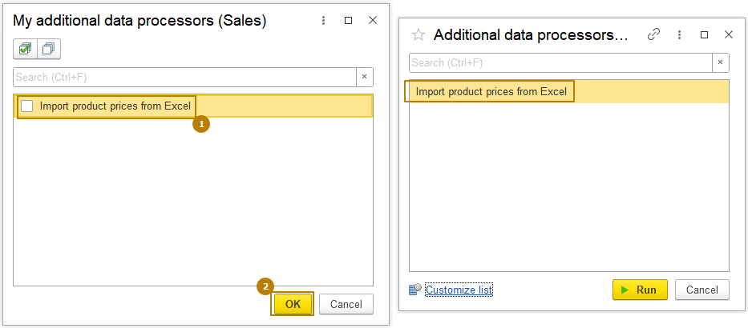
I don't see any point in considering the performance of the data processor, since this is not the subject of the lesson, the main thing is that we figured out how to connect additional data processors to the information base. If you make changes to the external data processor and want to update the additional processing, use the "Update from file…" button in the list form or the item form of the "additional reports and data processors" catalog.
Additional data processor of the "ObjectFilling" kind
Let's consider another kind of an additional data processor - "ObjectFilling". This kind of a data processor can be useful when it is necessary to add commands for filling one or more objects (for example, filling the "discount amount" column in the Goods tabular section of a document based on the numeric value of the discount size entered by the user: 5, 10 percent…). Data processor of this kind has different types of commands:
- Client method call
- Server method call
- Opening a data processor form
- Filling a form (one object without writing it to the DB. Other types of commands write the filled object to the DB)
Data processor of this kind can only be assigned (to some objects) and cannot be global like the data processor of the previous kind. In the forms of objects for which a data processor is assigned, a button or submenu (depending on how many filling commands are connected to the object: one or several) "Fill" appears on the form command bar, when clicked, the algorithm from the additional data processor is executed.
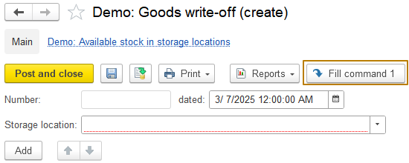
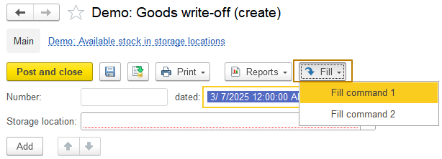
In order to correctly select the type of command, you should focus on the following questions in the order they appear:
- do you need to open your own form? If yes, then the type is "OpenForm"
- do you need interactive work with the user, for example, ask a question, provide input of a value ? If yes (and opening your own form is not required), then the type is "ClientMethodCall"
- do you need to write the object after filling ? (The answer to the previous questions is "no") If the answer to the current question is "yes", then the command type is "server method call", otherwise - "FormFilling".
One data processor can contain commands of different types, and accordingly can cover different filling scenarios.
Let's consider creating a data processor with commands of three types: "form open", "client method call" and "form filling". The last type "server method call" is the simplest and a few words and one screenshot will suffice about it.
The functionality of the data processor itself is not important in this example, let's take something understandable, for example, filling the Goods tabular section of the "Goods transfer" document with the balances of goods according to the data of the "Demo: Available stock in storage locations" accumulation register.
So, I create a new external data processor and call it "Fill goods with balances".
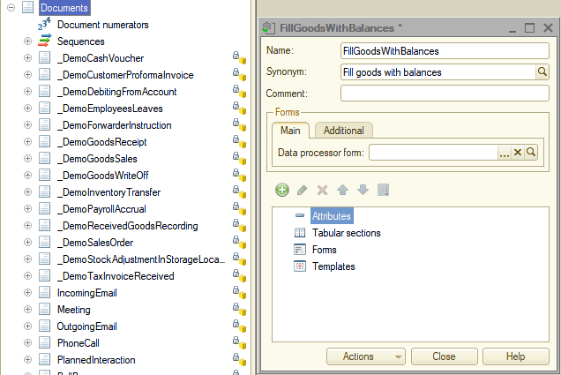
As you already know, now I have to create a function in the object module that returns information about the additional data processor
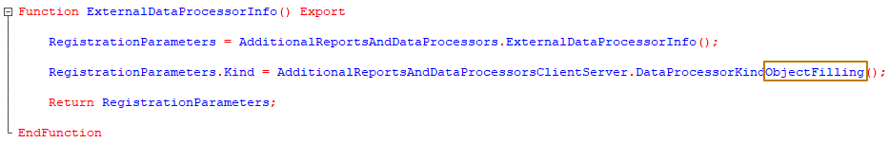
This time I fill the RegistrationParameters Kind property with the value "ObjectFilling". After that I specify the version "1.0" and information about the additional data processor.
Now I need to fill the array in the "Purpose" property with the names of the metadata objects for which this processing will be connected.
In my case, this is the document _DemoInventoryTransfer.
RegistrationParameters.Purpose.Add("Document._DemoInventoryTransfer");
This property does not have to be filled in, because you can select the objects to which the processing is connected when registering it in the system, but I recommend filling it in at the development stage so that the user does not perform additional actions that can lead to an error (a data processor can be connected to objects for which it is not intended, then its use in these objects can cause an exceptional error).
Now it remains to add the command(s) and I will start with a command of the type "ClientMethodCall". In order to better understand what a command of this type is needed for, let's imagine a situation: my data processor clears the data of the tabular section of a document, then fills it with the data of the balance of goods in the warehouse on the document date and then writes the document _DemoInventoryTransfer. If the user accidentally clicked on this button or he did not know that he would lose his data, he must be given the opportunity to cancel the action. Therefore, I want to display a question for the user "Tabular section will be cleared and then filled with the goods balances. Continue?" with the buttons "Yes" and "No" so that he can cancel the started action.
I add a row to the Commands value table and fill it in:
NewCommand = RegistrationParameters.Commands.Add();
NewCommand.Presentation = "Fill products with balances with warning";
NewCommand.ID = "FillProductsWithBalancesClientCall";
NewCommand.Use = AdditionalReportsAndDataProcessorsClientServer.CommandTypeClientMethodCall();
In this case, I fill in the Presentation and ID properties with the values that are convenient for me, so that it would be easier to distinguish them both in the code and in the interface in Enterprise mode.
To ensure the operability of a command with the "Call a client method" type, it is necessary that the data processor has a main form, in the module of which there is an export client procedure ExecuteCommand(CommandID, RelatedObjectsArray). In this case, no other settings of the form are required: commands, attributes, elements.
I create the main data processor form (it is important that this is a form that is assigned as the main data processor form):
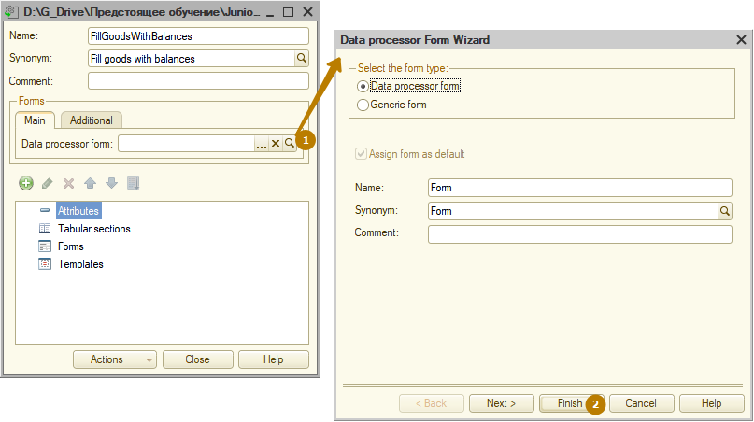
And I add the export procedure ExecuteCommand to its module:
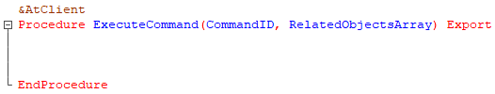
You can stop here, save the external data processor and try to register it in the information base.
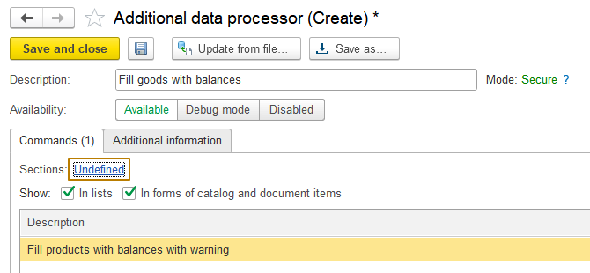
When registering the data processor, the Sections field contains the value Undefined, although I filled in the Purpose property in the ExternalDataProcessorInfo() function. If I try to fill in the Sections in Enterprise mode, I will see that the list of objects to which the data processor of the "Object filling" can be connected does not include the _DemoInventoryTransfer document. As in the situation with subsystems in which global data processors can be placed, when we had to enable a change for some vendor configuration objects, the situation with assigned data processors is similar. The configuration object "Object with additional commands" of the "TypeCollection" type is responsible for the list of objects to which the assigned data processor can be connected.
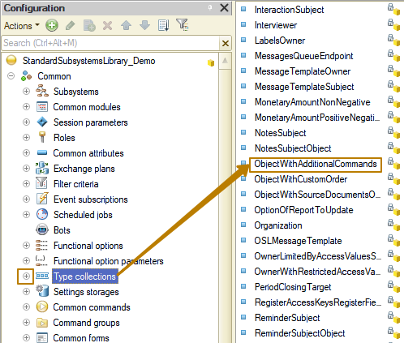
In order to include the _DemoInventoryTransfer document in the list of objects for assigning additional data processor of the "Object filling", you need to enable the ability to change this metadata object and add the document to the list of types.
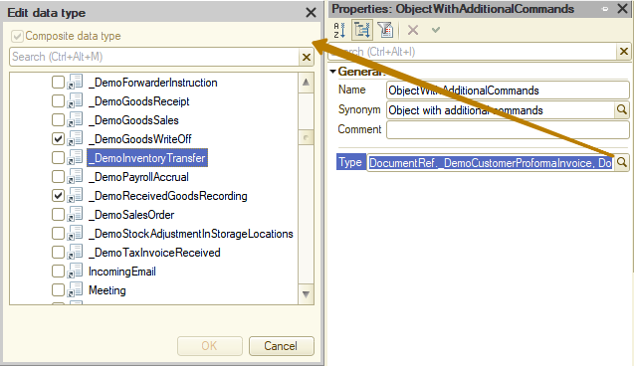
After completing these steps, I update the DB configuration and try to register the data processor in the system again. Now the Sections is filled in correctly automatically when registering the data processor in the system.
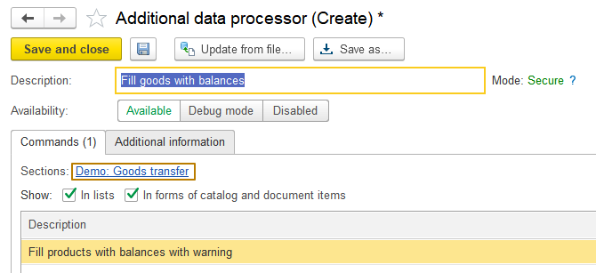
Let me open the document to check if it has a new fill button. In order to find a document in the interface, you can use the search by functions, which is available in each section of the interface:
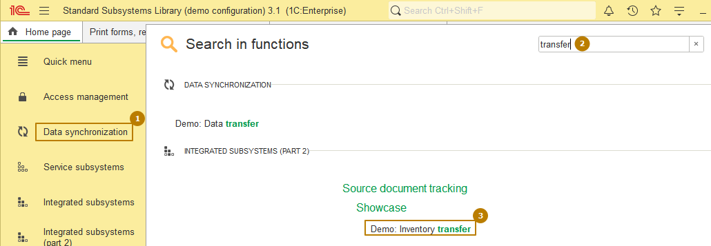
A "fill" button has appeared in the list form and the document form, and due to the too long presentation of the command, the button is displayed as only a picture without text, but the text is displayed in the tooltip when you hover the mouse over the button.
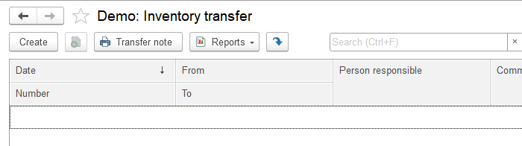
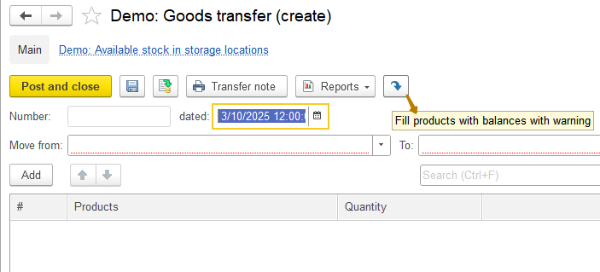
When you click on the filling button in a newly created document that has not been written to the database, a question box appears stating that the object must first be written to execute the command and asking whether to agree to the its writing or not.
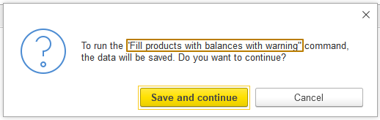
I agree to write the document and nothing happens because the command contains an empty handler. I need to add code to display a question to the user asking whether he agrees that the tabular section of the document will be cleared and then filled with the goods balances, after which the document will be saved. If the user refuses (clicks the "No" button), the command execution must be stopped.
I will not implement all the code for filling a document, since this is not the subject of the current lesson, I will only show the important information.
In the ExecuteCommand procedure, I recommend adding a check for the command identifier even if you only have one command in data processor, since in the future, you or another developer can add one or more commands with the type ClientMethodCall and then this procedure will be called when calling several commands.
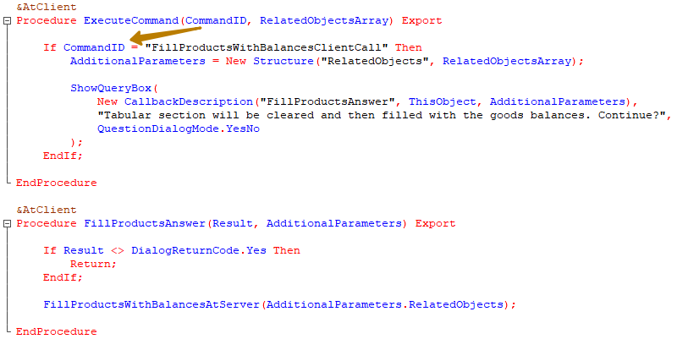
You can only get, modify, and write an object by reference at the server side, so I must pass references to the objects being processed to the server procedure. Remember that when connecting the filling data processor to an object list form, one command call can contain several references to objects at once if they were selected in the list form. Therefore, to minimize the number of server calls, you should pass all references to objects from the client at once.
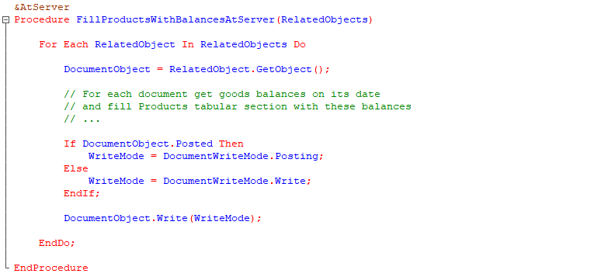
When writing a document, you should check whether it was posted. If so, then the writing must be done in the Posting mode, otherwise in the Write mode. I recommend recording the object inside the Try block to handle exceptional errors yourself.
In order for my data processor to at least slightly change the object and I could immediately understand that the processing was successful, I will fill in the document comment with the following text: "Written from the filling data processor in <CurrentTime>".
I update the additional data processor in the information base, return to the document and call the filling command, agree to clear the tabular section:
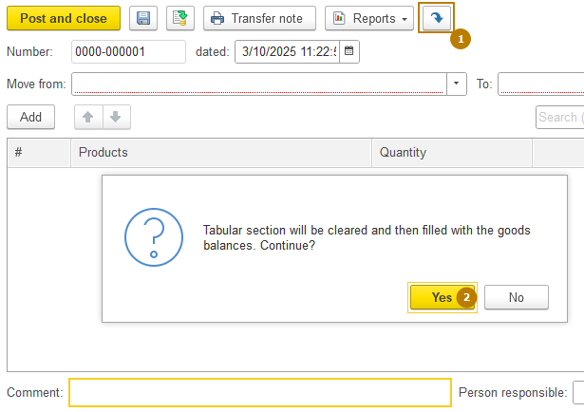
Visually, nothing has changed, the comment remains empty. I close the document and return to the list form, where I see that the document comment is filled in.
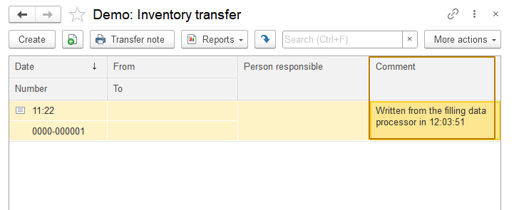
It turns out that when a document is recorded programmatically with an open document form or list form, the data is not reread after the object is recorded, so the user does not see the changes. In order for the data in the dynamic list to be reread after the filling process is complete, you can use the
NotifyChanged(ObjectRef)
method where you can sequentially pass all the refs to the changed objects or pass the type there NotifyChanged(Type), an example of the type:
NotifyChanged(Type("DocumentLink._DemoMovementOfProducts"))
then the dynamic lists will be updated, where the main table is a table of the specified type.
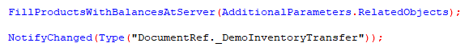
Unfortunately, the data of the open document form will not be reread (updated) when the NotifyOnChange method is called. It can be updated by clicking the Reread button in the "More actions" submenu:
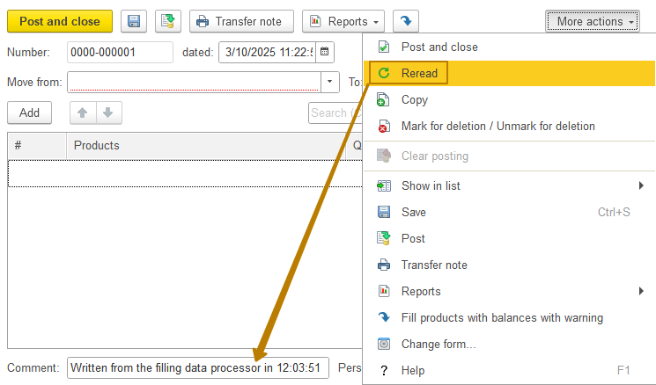
Here is how filling objects from the list form looks like, an additional step is added here - selecting the filling command:
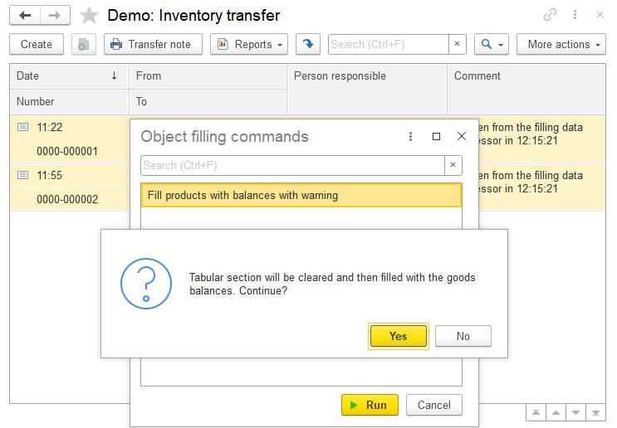
Let's move on to the next command type - "Form open". Let's describe the task it should solve. Let's imagine that some warehouses contain a huge number of balances of various types of goods, and a user wants to fill out the goods transfer document using the new command only with goods related to a certain type/group. Then, to the algorithm we have already implemented, we should add the ability for the user to specify a certain filter. Let it be a filter by the inclusion of the product in the hierarchy of the specified group. Our task will be to provide the user with a form in which he must specify the product group and click the "Fill goods" button, after which the tabular section of the document will be filled with the balances of goods from the hierarchy of the specified group. When calling the command, we should still ask whether the user agrees to continue filling. If the user refuses, we need to close the opened data processor form.
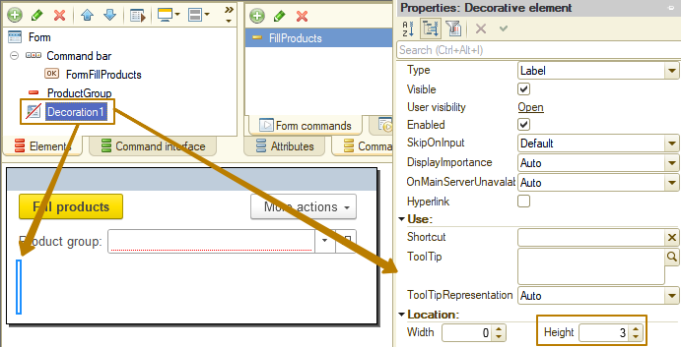
You can see that I added the decoration of the "Label" type with a height of 3 so that the form is not too small vertically, since when messages are displayed in the window of this form, the message panel will overlap important elements of the form. The decoration itself is not visible to the user and does not carry any other semantic load except for adding an indent.
As in the case of the "Client method call" command type, the data processor must contain a main form, but now this form will be opened when the data processor command is called. Also, in the case of the "Object filling" type of a data processor, this form must contain the RelatedObjects parameter of the Arbitrary type. An array of references to objects for which an additional data processor is performed is passed to this parameter:
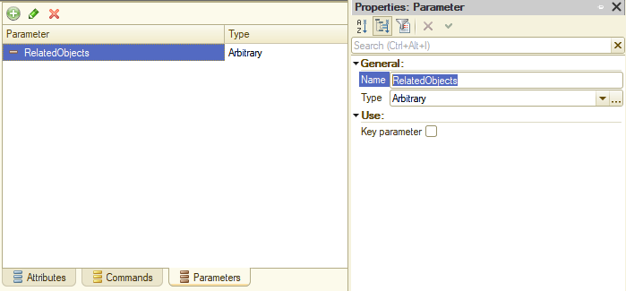
In addition to this parameter, two more parameters are passed to the form when it is opened: CommandID (String(0)) and AdditionalDataProcessorRef (CatalogRef.AdditionalReportsAndDataProcessors), the second parameter contains a link to the AdditionalReportsAndDataProcessors catalog element that is associated with this additional data processor. In order for the parameters to be available in the OnOpen event handler, you need to enable the "Key parameter" flag for them, otherwise they will be deleted from the form Parameters structure at the end of the form creation event
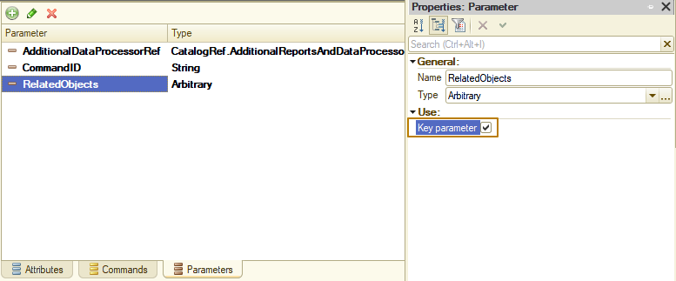
Information: the "Key parameter" property of a form parameter is intended to make the parameter available throughout the entire period of use of the form, and not only when it is created.
Now I need to add code to the ExternalDataProcessorInfo function to add this command to the Commands value table.
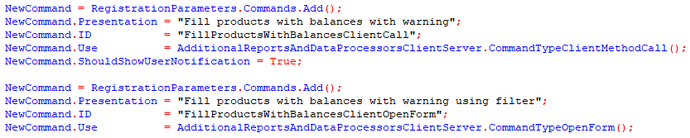
You can see that I added the ShouldShowUserNotification property to be filled with True for the command with the ClientMethodCall type. This is needed in the case when you want the client to receive a custom notification in the corner of the program when the command is called.
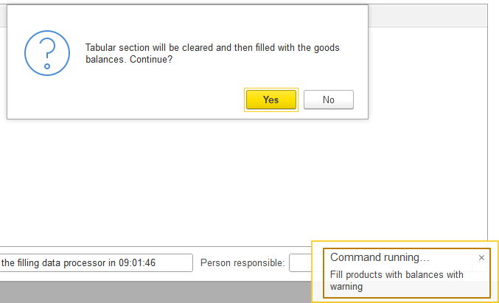
I save the changes to the external data processor and update the additional data processor in the infobase. After that, I open the _DemoInventoryTransfer document and see the filling submenu, which now has 2 commands, I call a new command with the OpenForm type:
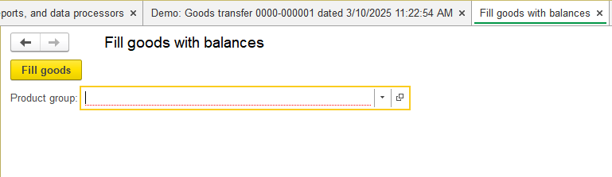
I don't like that this form opens in full screen. In order for it to open in window mode over the owner's window (the form from which it was called), you need to change the value of the WindowOpeningMode property to "Lock owner's window".
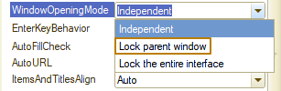
Okay, now you need to add a question to the user immediately when opening the form, because if he refuses to fill out the document and record it in the DB, then there is no need to require him to fill out the product group for filter.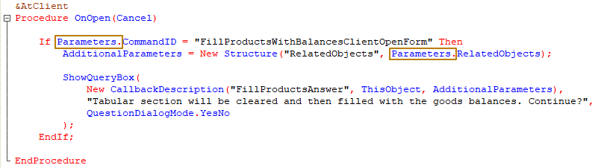
You may have noticed that the code of the OnOpen event handler procedure is almost identical to the code of the ExecuteCommand procedure that was called for our first command. In the case of real development, I would move the code inside the command ID check into a separate procedure and call it from both commands to avoid duplicating code.
In order to close the form if the user refuses to continue, I add the code for closing the form, but place it inside the check for the form being opened, since trying to close a form that is not opened causes an exceptional error.
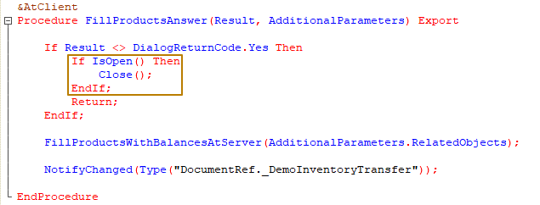
The code for closing the form after filling it should also be placed in the "FillGoods" command handler, otherwise it will remain open.
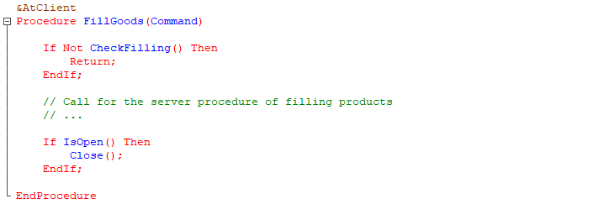
The last thing I would like to show is the transfer of the value from the form parameters from the client to the server, because there are some nuances there. When calling the server and passing the parameter to the procedure or function "by reference" (that is, when the procedure or function description does not have the keyword "Val" before the parameter), the value is transferred between the client and the server twice - from the client to the server and back from the server to the client. Some objects cannot be returned from the server to the client for technical reasons, for example, the value of the Array type, which is stored in the form parameters. When attempting such a server call, you will get an exceptional error when returning control to the client:
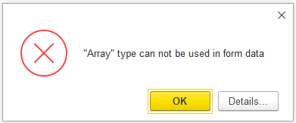
But we do not need to return the value to the client in this case, so you can simply add the keyword Val before the server procedure parameter:
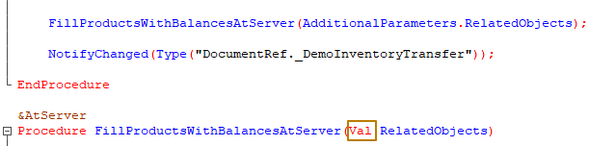
At this point, we can finish our acquaintance with the "OpenForm" type command and move on to the third type of commands from those that we planned to consider - "FormFilling". The main difference between this type of command and other filling data processor commands is that instead of filling out an object, the opened object’s form is filled out without saving it to the DB, so the user immediately sees the result of filling out, can edit the object before writing or refuse writing the object by closing the form without saving. Also, since there is access to the open form of the object, you can call the export methods of the form module, you can call other methods that accept a form as input parameter, passing this form to it. The limitation is that you cannot use such a command from the list form, it can only be connected to the object form.
I add this command to the Commands table of the ExternalDataProcessorInfo function:
To use this type of command, I must create an export procedure ExecuteCommand in the object module with 3 parameters: CommandID, RelatedObjects, and ExecutionParameters.
The ExecutionParameters parameter has a property ThisForm, which contains the form of the object being filled. In order to work with the object in terms of filling it, you can access the main attribute of the form, which, as you remember, is called Object by default, and fill it as if we were filling an application object (DocumentObject, CatalogObject…).
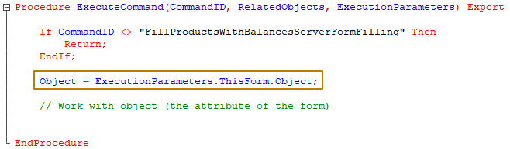
In order to test the functionality of the new command, as in the case of the previous commands, I will change the document comment.
I update the additional data processor and check the execution of the new command. As a result, I received an error:
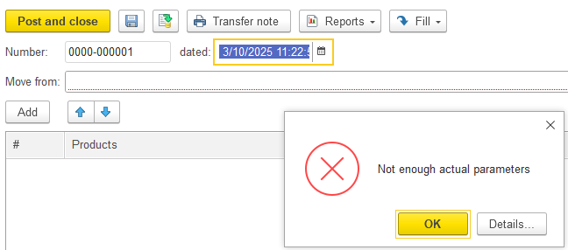
The thing is that when registering an external data processor without specifying the SSL version, the server procedure ExecuteCommand will be called without the third parameter ExecutionParameters, which will lead to an error if this parameter is mandatory. But we cannot process the command without this parameter, since in this case we will not be able to work with the form and its main attribute. Therefore, I will add the passing of the SSL version to the ExternalDataProcessorInfo function. Please note that I do not specify the version manually, but call the method from the common library module so that the work of the data processor continues to work correctly even after updating the library to a new version as part of the configuration:
This command is not available in the list form:
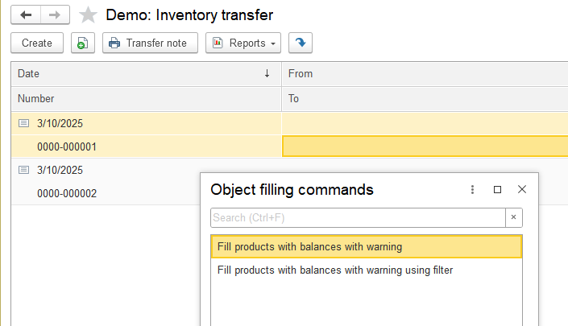
But in the document form it is available:
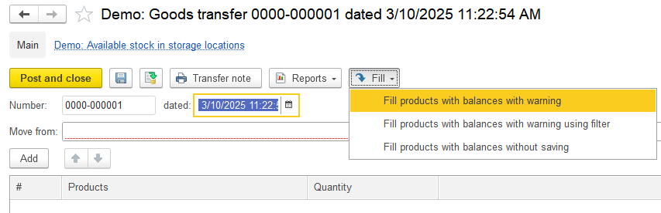
Tip: Please note that the "form filling" command does not set the form modification automatically. If you want to show a user that the object has been changed and he may lose the changes when closing the form, I recommend setting the modification manually.
So, we have considered 3 types of additional data processor commands with the "Object filling" kind. To implement a command of the "Server method call" type, it is enough to create an export procedure ExecuteCommand(CommandID, RelatedObjects, ExecutionParameters) in the data processor object module, i.e. exactly the same as we created for the "Form filling" type command. All the necessary information about what actions need to be taken when implementing a particular command can be obtained from the description of the service procedures and functions of the subsystem. For example, information that you must create exactly the procedure described above with a certain set of parameters can be found in the description of the AdditionalReportsAndDataProcessorsClientServer.CommandTypeServerMethodCall() function.
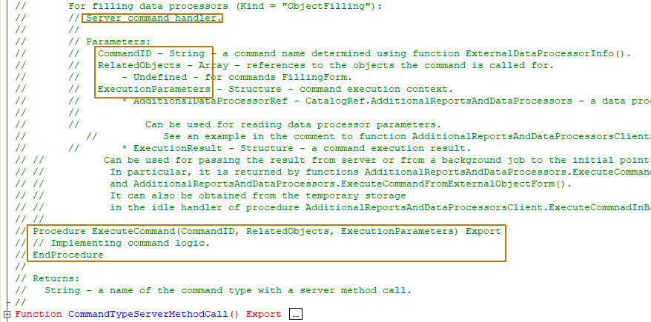
This concludes the review of additional processing of the "Object filling" kind.

